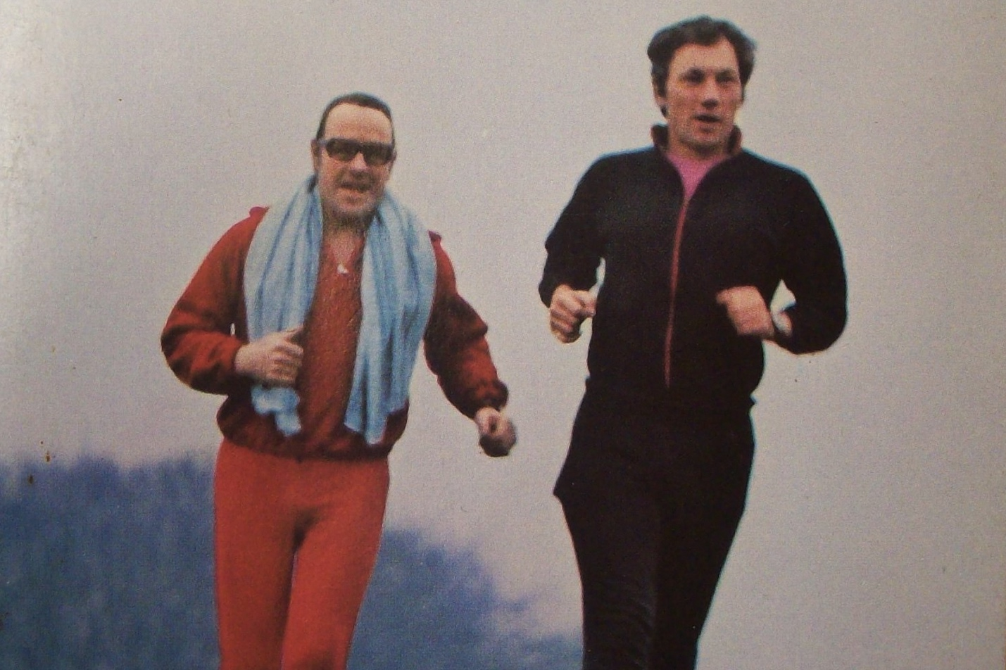
Source: Cover of Jogging, by Bill Bowerman and W.E. Harris, 1970 edition

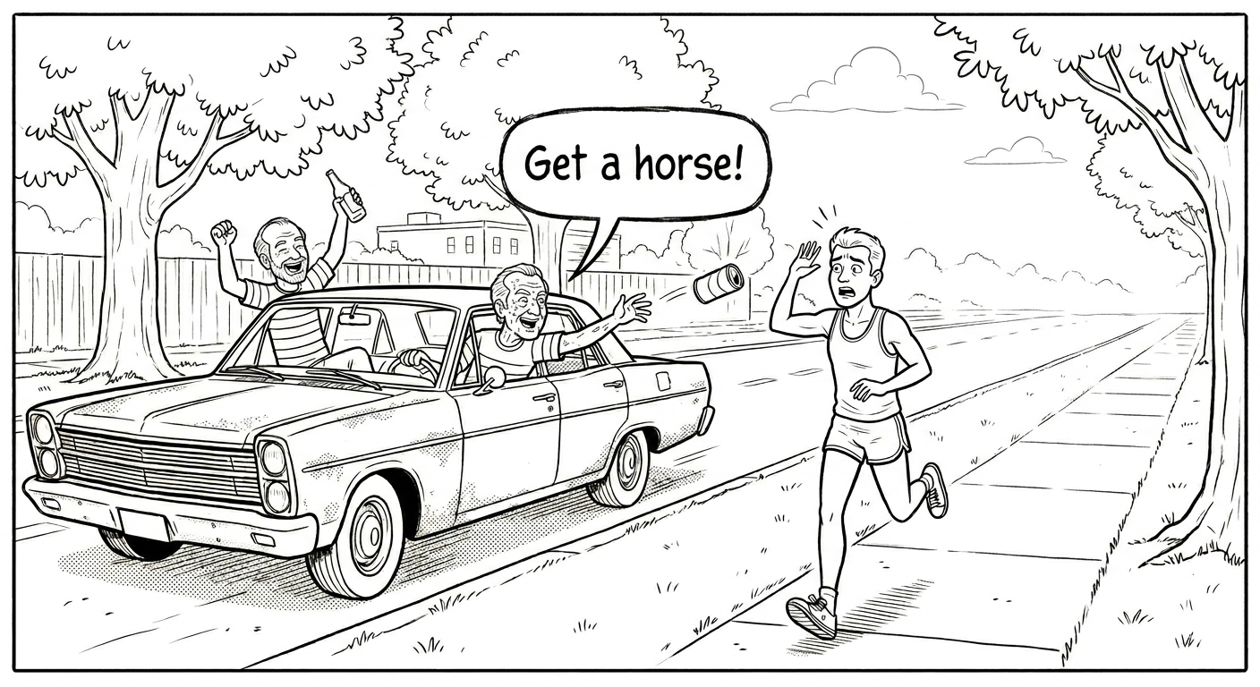
Source: Google Gemini Image Generator (Original Prompt)

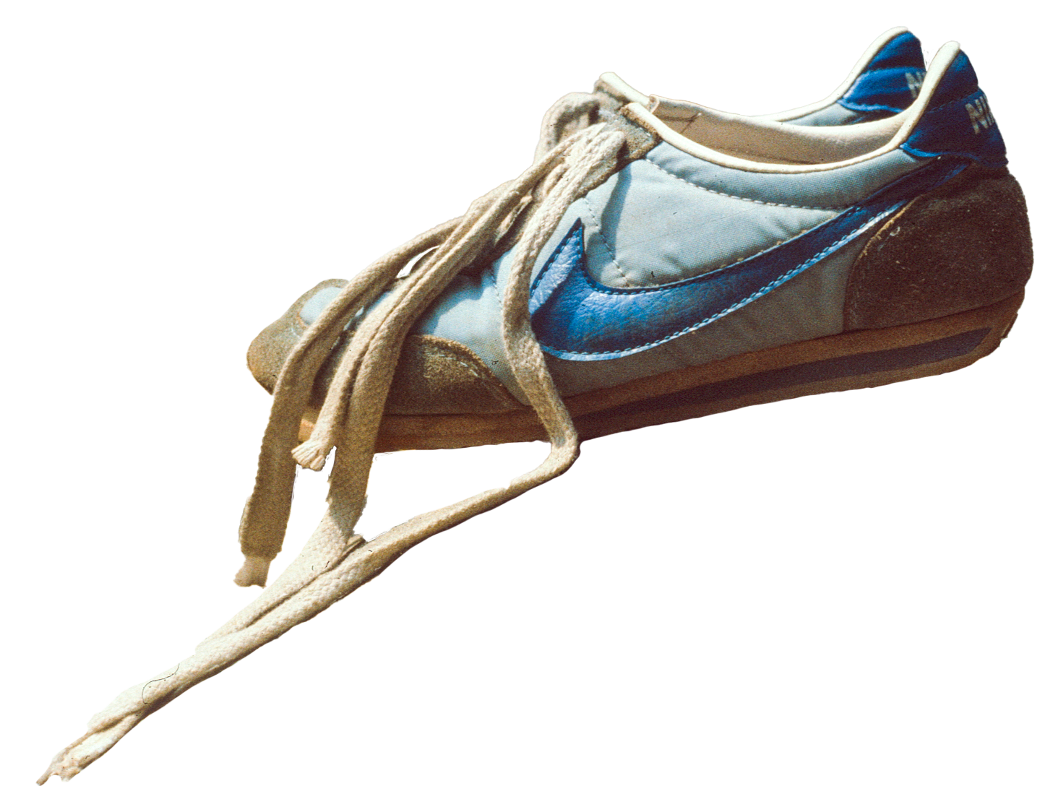
Source: New York Times 2025

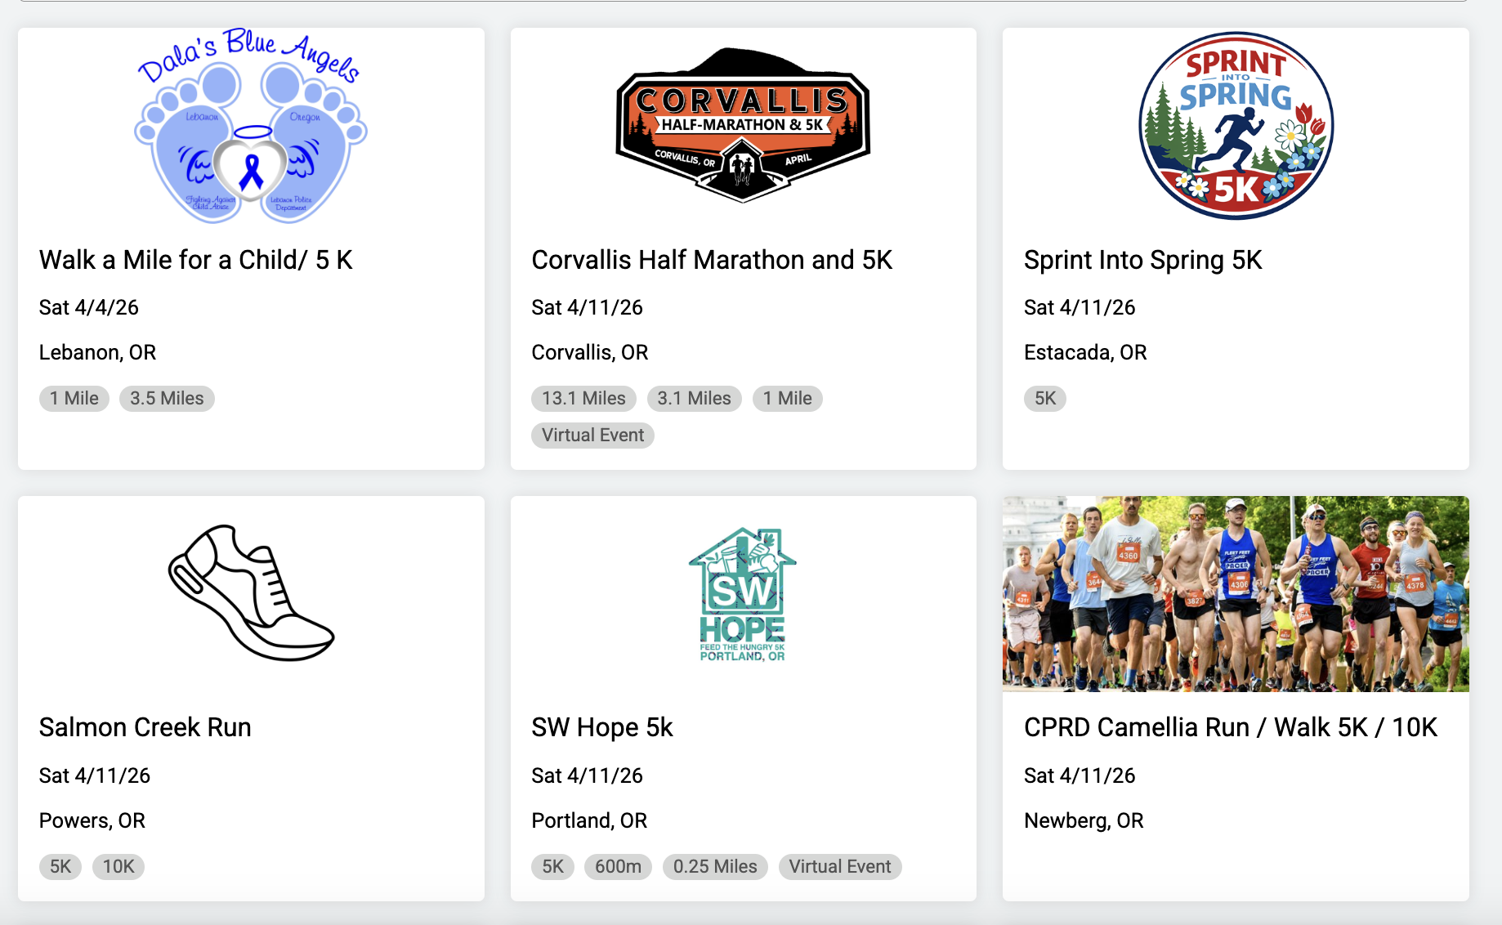
Source: RunSignup.com accessed 4/3/2026


Sources: shamrockrun.com, whisperrunning.com, hoodtocoast.com
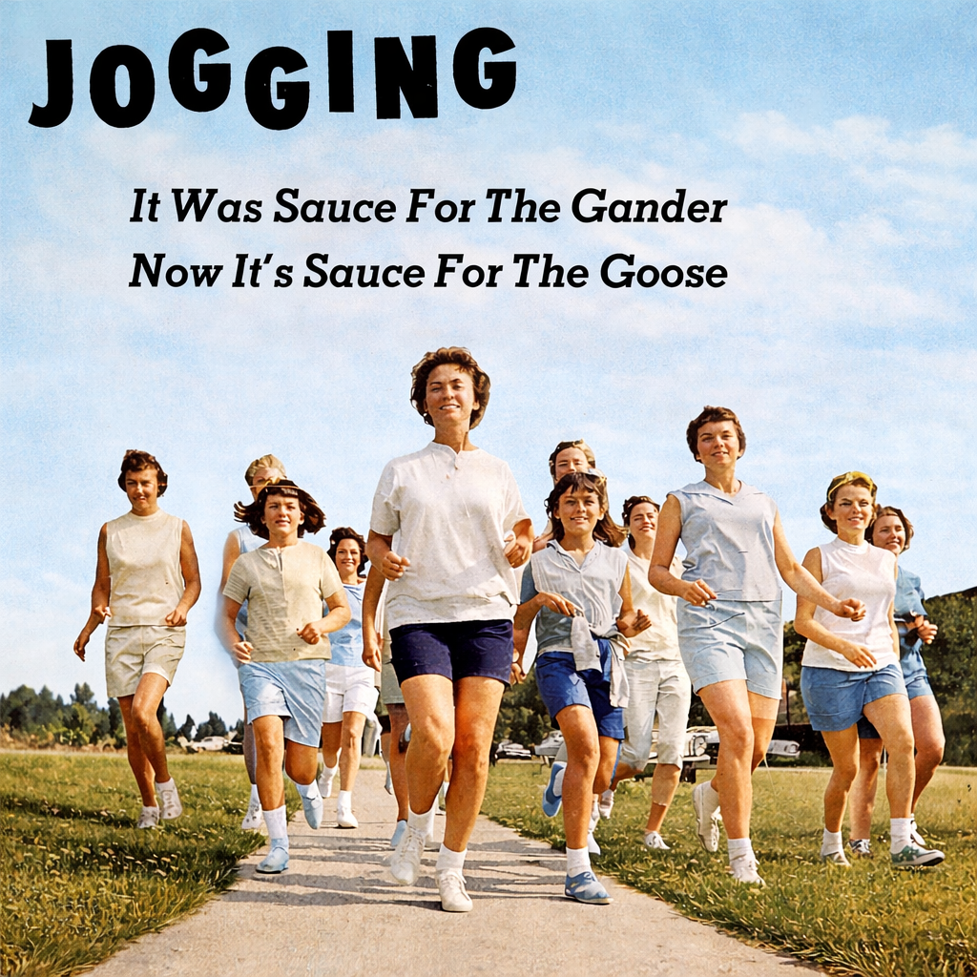
Source: Oregonian, 1965 (Colorized by ChatGPT)

Colorized photo (ChatGPT) of Oregonian (Portland, Oregon), August 29, 1965: 152. NewsBank: America's News – Historical and Current. https://infoweb-newsbank-com.proxy.multcolib.org/apps/news/document-view?p=AMNEWS&docref=image/v2%3A11A73E5827618330%40EANX-NB-12E8A160D9A7BE7F%402439002-12E69E02925B24A9%40151-12E69E02925B24A9%40.

Butte to Butte Participation Estimates Over Time
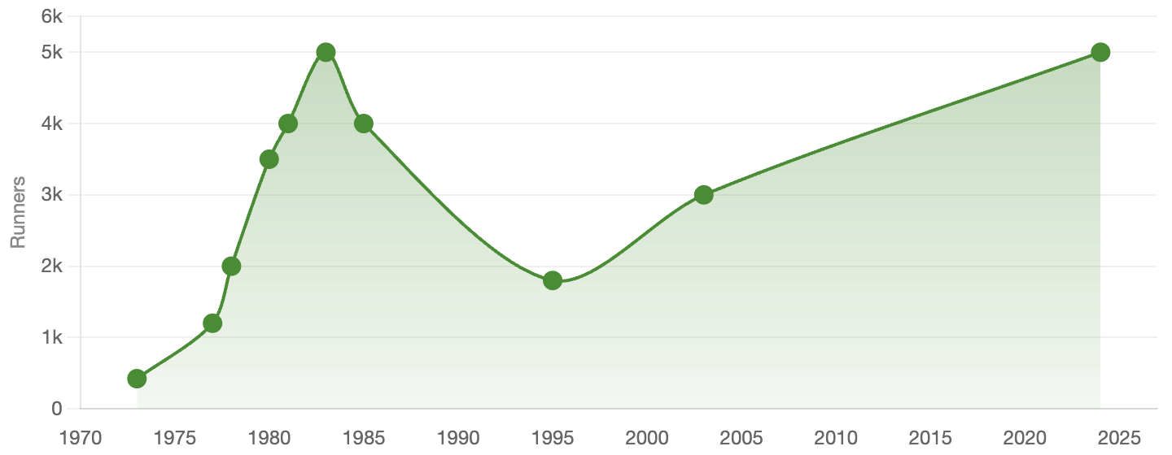
Source: Register Guard Reporting, various years

The first Butte to Butte was called Storm the Butte and had 423 participants. In that race they ran up Spencer’s butte on the back side which caused several injuries. The next year they changed the race to run from Spencer’s butte to Skinner’s butte, thus being called henceforth the “Butte to Butte”.

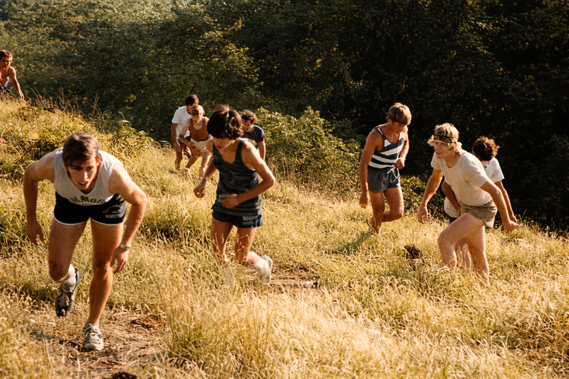
Source: Register Guard 2024

The fourth Butte to Butte, in 1977, had 2,500 participants.

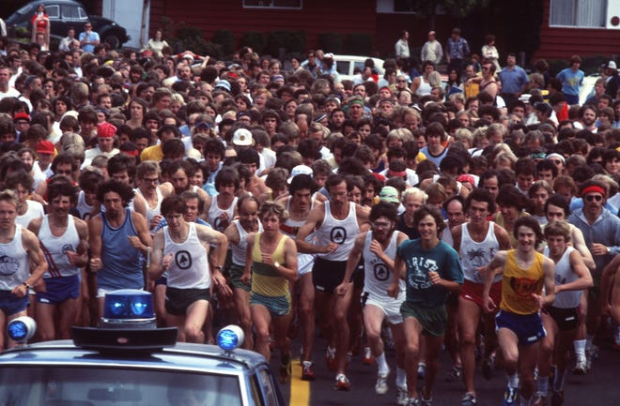
Source: Register Guard 2024

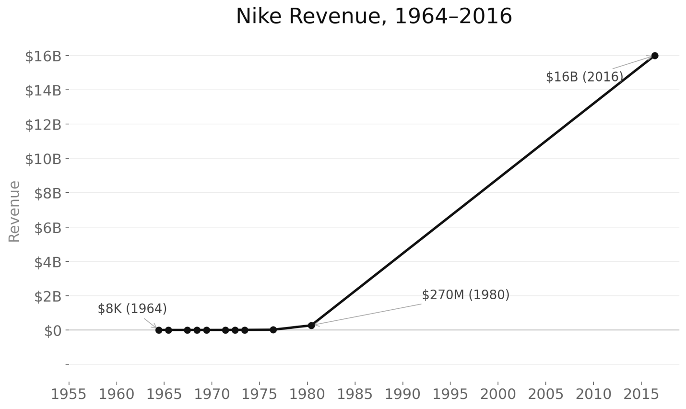

Source: Data from Phil Knight (2016). Chart made with Claude.
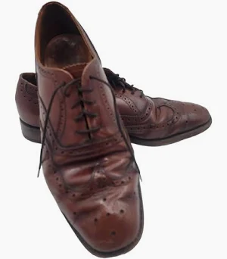

Bill Bowerman’s 1967 book, Jogging, was co-authored by a heart specialist. It helped the revolution because people realized jogging was in fact good for you.

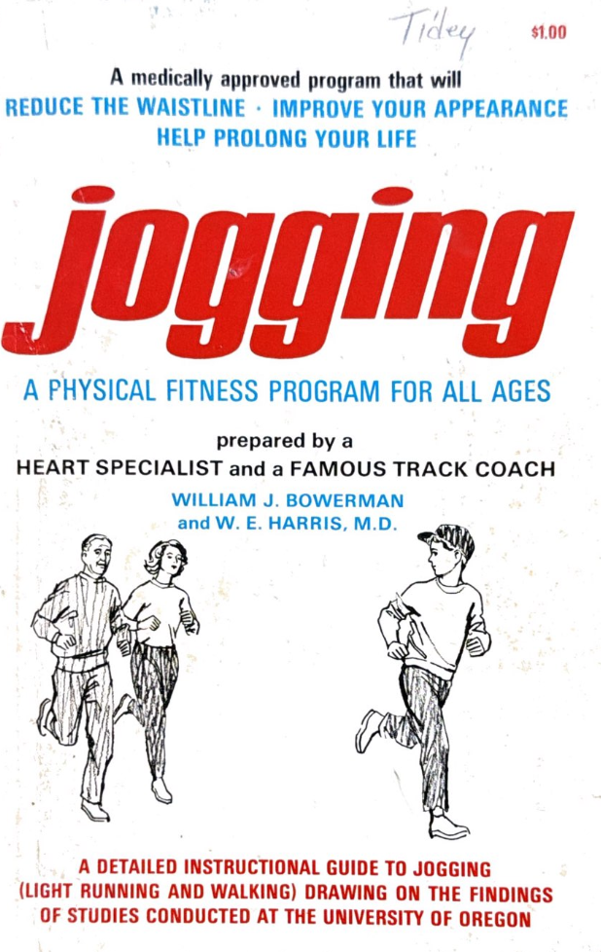


Source: Bowerman Track Club 2025

